**9238-MANGAYARKARASI COLLEGE OF ENGINERING**

IOT

(Approved by AICTE New Delhi & Affiliated to Anna University, Chennai)

MANGAYARKARASI NAGAR, PARAVAI, MADURAI - 625 402

Website: http://mce-madurai.ac.in E-Mail:: mangai.enggcoll@gmail.com

**SMART WATER MANAGEMENT**

*PHASE-4*

PROJECT MENTOR

R.M.SENTHIL KUMAR

J.GAYATHRI (923821106015)

A.BHUVANESHWARI (923821106012)

C.JAYANTHI (923821106020)

M.MAHALAKSHMI (923821106022)

S.PRIYADHARSHINI (923821106039)

SMART WATER MANAGEMENT

(PHASE-4)

# **INTRODUCTION:**

* Smart Water Management is the activity of planning, developing, distributing and managing the use of water resources using an array of IoT technologies which are designed to increase transparency, and make more reasonable and sustainable usage of these water resources
* Smart water management systems can provide a more resilient and efficient water supply system, reducing costs and improving sustainability. High-technology solutions for the water sector include digital meters and sensors, supervisory control and data acquisition (SCADA) systems, and geographic information systems (GIS).

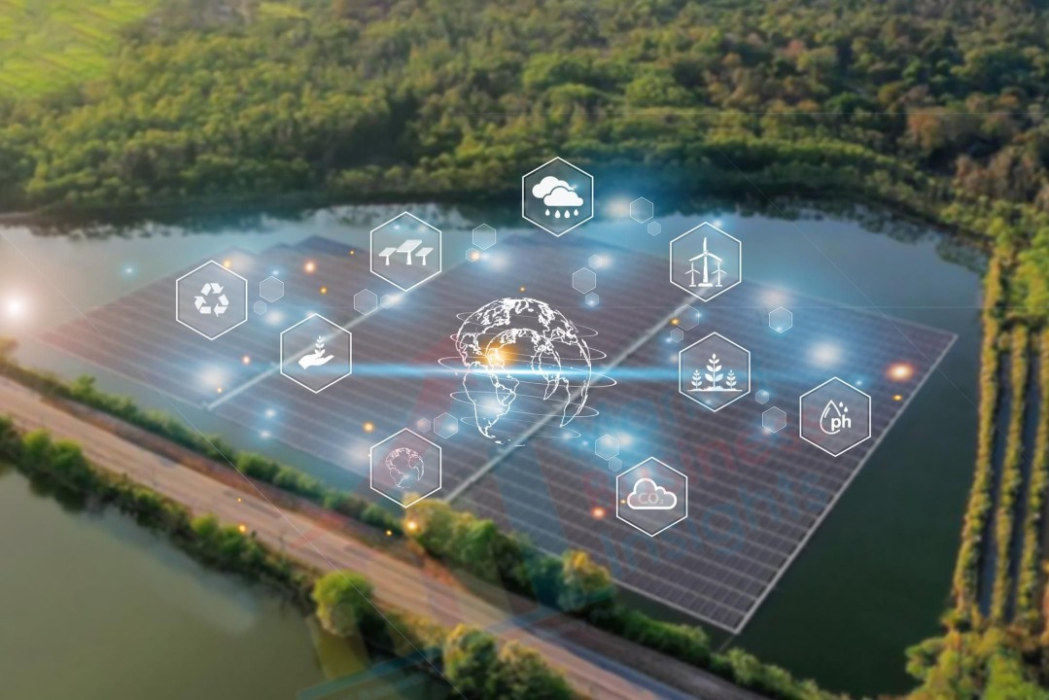

**SMART WATER MANAGEMENT:**

* Water scarcity issues are forcing the water management sector to develop smart water systems that improve efficiency and sustainability.
* IoT connected smart water solutions are being deployed to monitor, control and regulate the usage and quality of water.

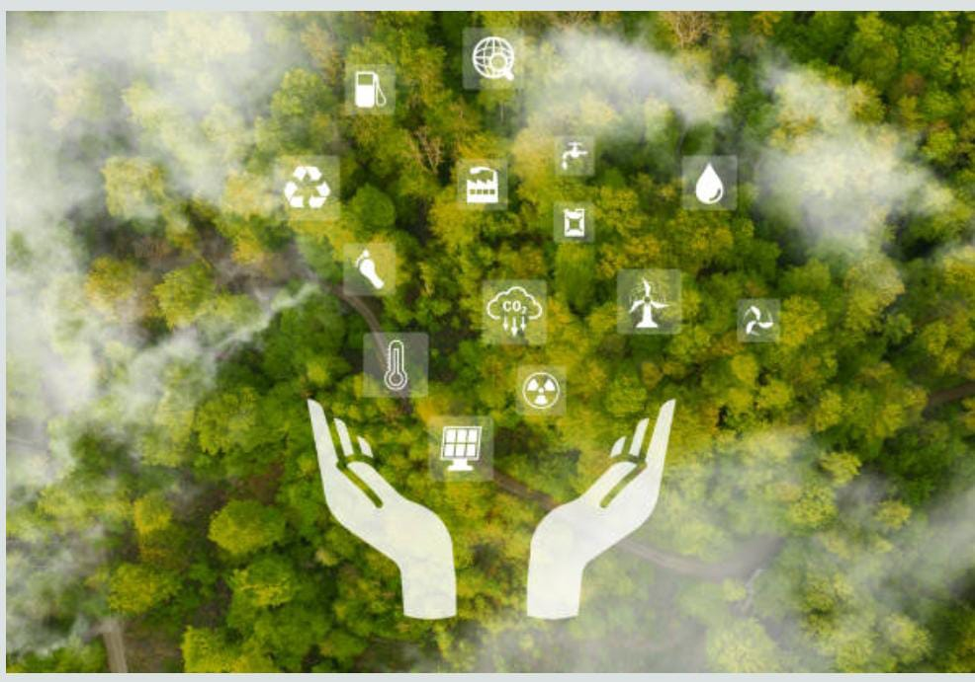

* Equipment like sensors, smart water meters, data processing software and control systems are helping smart water management systems overcome outdated technology and increasing labour costs.

SIMULATION PROCESS

**WOKWI**:

* Wokwi is a platform that allows you to simulate and test your code for microcontroller-based projects, including those written in Python for microcontrollers like the ESP32. To implement an environmental monitoring system in a park using Wokwi, you'll need to follow these steps:

**1.Create a Wokwi Account:**

* Start by creating an account on the Wokwi platform if you don't have one already.

**2.Select the Microcontroller:**

* projects, the ESP32 is a popular choice due to its built-in Wi-F In Wokwi, choose the microcontroller you want to work with. For smart water management capabilities.

**3.Design Your Circuit:**

* Using Wokwi intuitive drag-and-drop interface, design the circuit for your smart water management. This may include adding sensors (e.g., DHT11 for temperature and humidity), LEDs, and any other components you need.

**4.Write the Python Code:**

* In the Wokwi interface, you can write Python code to interact with the sensors and control the microcontroller. For example, you can use the machine module to configure pins and sensors and the requests module to send data to a server or Things peak.

**5.Simulate Your Project:**

* Click the "Run" button to simulate your project. You can observe how your Python code interacts with the virtual environment, sensors, and microcontroller.

**6.Test and Debug:**

* Use the simulation environment to test your code for smart water management. You can check if the temperature and humidity readings are correct and if your data sending function works as expected. If any issues arise, use the debug tools provided by Wokwi to identify and resolve problems in your code.

**7.Save Your Project:**

* Save your project on Wokwi so you can access it later or share it with others.

**8.Explore More Sensors and Components**:

* You can expand your project by adding more sensors and components to simulate a comprehensive Smart water . For example, you can add sensors for air quality, light, or GPS to gather more data.

**OUTPUT IN WOKWI:**

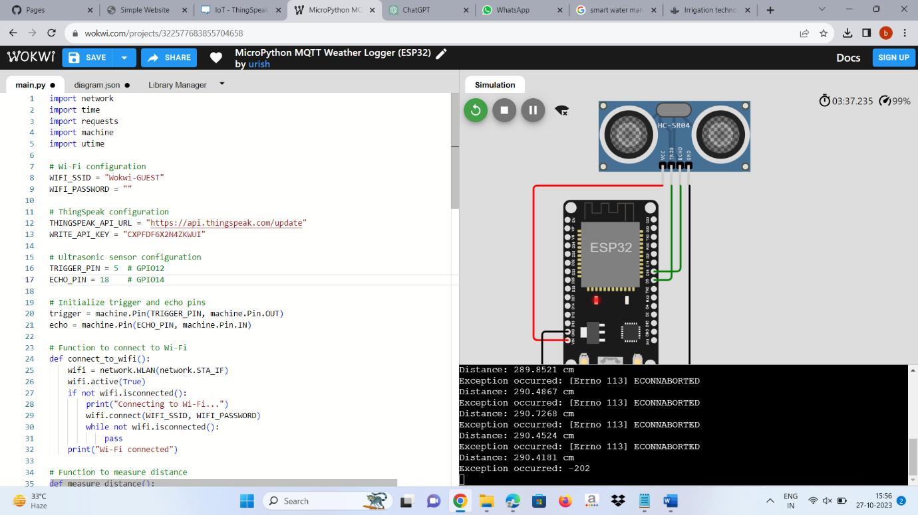

The two different outputs are shown

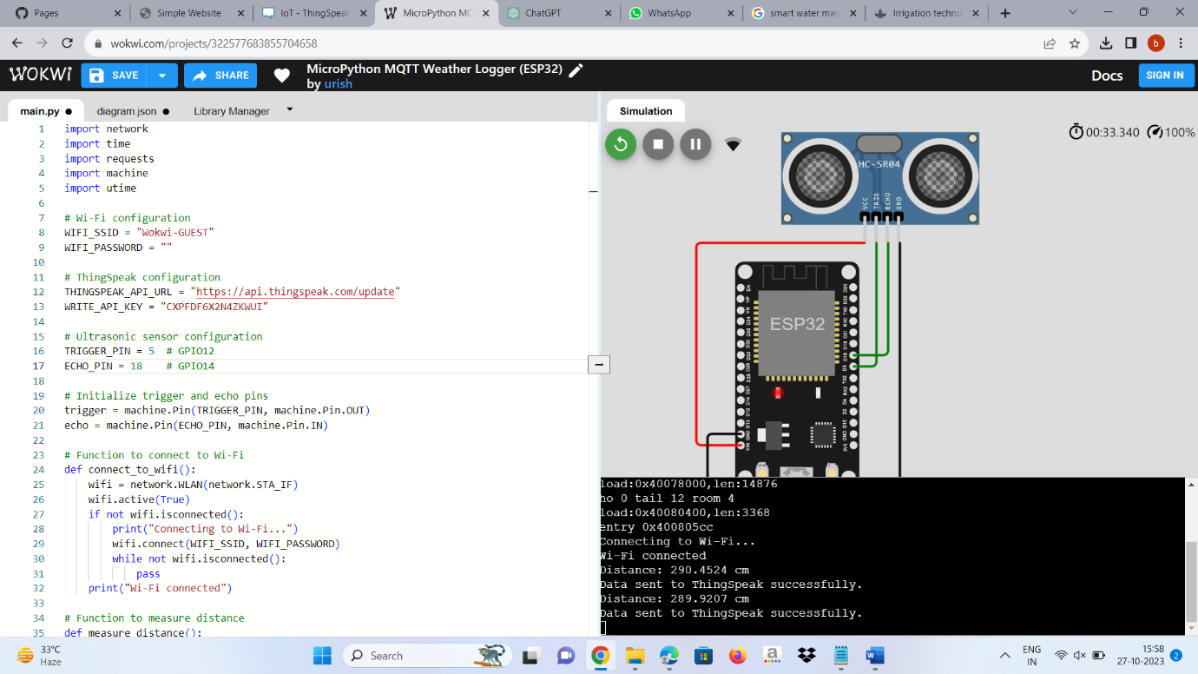

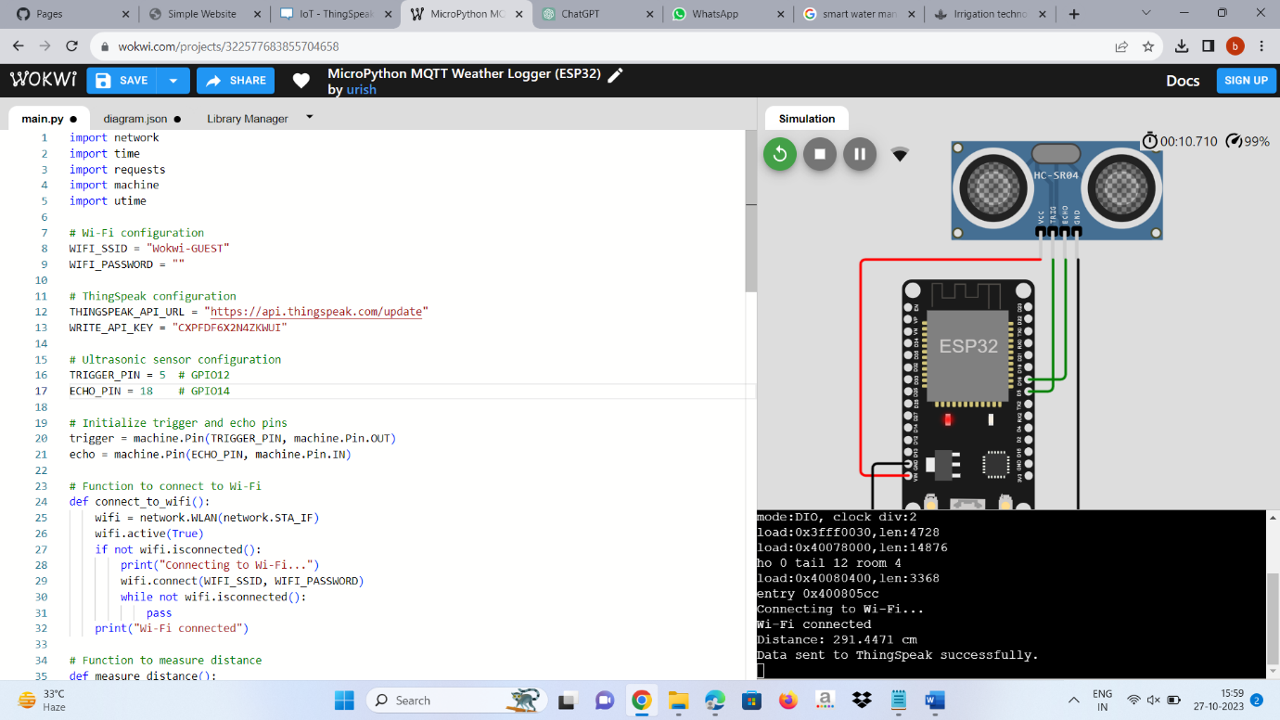We can adjust the Temperature and Humdity level of the sensor because this is the simulation process not having a physical components.

* The Following Library Files are used in WOKWI
* We Must include The Library Files

1. DHT22
2. Soil Moisture Sensor
3. Ultrasonic Sensor
4. Wifi
5. ThingSpeak

**THINGSPEAK:**

* ThingSpeak is our chosen server for your smart water management project

**1.Set Up ThingSpeak Account:**

* If you haven't already, create an account on ThingSpeak (<https://thingspeak.com/>).

**2.Create a ThingSpeak Channel**:

* In your ThingSpeak account, create a new channel. This channel will be used to store the data from your environmental monitoring system.

**3.Note Your API Key:**

* In the channel settings, you'll find an API Key. You will need this key to send data to your ThingSpeak channel

**4.Integrate ThingSpeak in Your Python Code:**

* In your Python code running on Wokwi, use the requests library to send data to ThingSpeak. You can construct a URL with your API Key and the data you want to send.

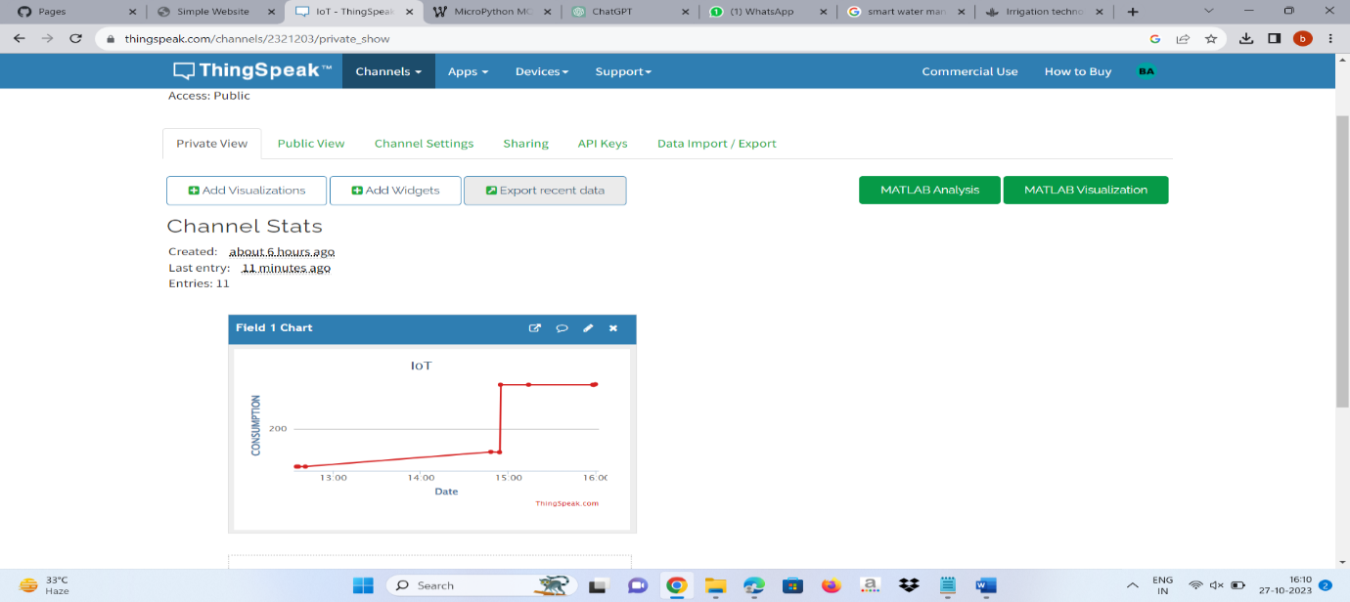

* organized design elements, allowing users to track smart water management trends and make informed decisions. Our website is a valuable resource for both casual observers and serious environmentalists, offering a seamless and enjoyable experience for exploring and understanding the world around us.
* YOU CAN ACCESS OUR WEBSITE USING THE BELOW URL

<https://Bhuvaneshwari2709.github.io>

**CONCLUSION:**

* Traditionally, water management policies and practices have dealt only with problems of water distribution to meet the ever-increasing demand, rather than better management of existing resources.

The largely fragmented approach that results has contributed to the overexploitation of water resources.